LSA Trial – PARIS – S1 2016
An industrial LSA trial took place during the first semester 2016 in Paris managed by Ericsson, RED Technologies, and Qualcomm. The analysis of result of this trial, provided by these stakeholders, is detailed hereafter
Feedback from the recent Ericsson, RED Technologies, and Qualcomm trial
The feedback provided hereafter has been developed with the support of various entities contributed to the LSA trail to demonstrate, using latest commercial LTE radio network and user equipment, timely spectrum availability upon request from incumbent.

Background
Spectrum sharing offers the potential to greatly increase spectrum efficiency and unlock extra data capacity.
To validate, in the present case, that LSA can safeguard both existing incumbent and new users, Ericsson, RED Technologies, and Qualcomm have initiated an LSA field experimentation in Paris, France.
This initiative received the active support of the ANFR, the French regulator ARCEP and the French Ministry of Defence.
The main purpose was to demonstrate, using latest commercial LTE radio network and user equipment, timely spectrum evacuations upon request from incumbent users while keeping LSA licensee users with uninterrupted broadband connectivity.
This was achieved thanks to the combination of Ericsson’s latest Carrier Aggregation technology with RED Technologies’ spectrum assessment and management technologies.
These solutions, combined within a state-of-the art LSA user framework enabled by Qualcomm Technologies and applicable to 5G, were a powerful world first.
The French regulatory authority ARCEP and the Ministry of Defence authorised the use of the 2.3-2.4 GHz band for the LSA pilot (trial).
The LSA pilot run uninterrupted and successfully over 6 months, served for demonstration events, internal research & development, and dissemination in standards.
The pilot was completed in June 2016.

Pilot Fundamentals
The LSA pilot consisted in a field test introducing live mobile broadband service under Licensed Shared Access (LSA) regulatory and technology framework as per CEPT (European Conference of Postal and Telecommunications) and ETSI (European Telecommunication Standardization Institute) definition in line with the recommendations of the RSPG Opinion on LSA.
The pilot used 2 x 15 MHz frequency aggregated carriers on IMT TDD Band 40 (2.3-2.4 GHz) on a dedicated areas (Red Technologies premises in Paris). The second carrier was operating under LSA restrictions as Secondary Component Carrier (SCC) while the first carrier was not subject to LSA restriction (Primary Component Carrier) to guaranty service continuity to LSA licensee users.
The allocation of channels followed E-UTRA Channel Bandwidth as per 3GPP TS 36.101.
The LSA pilot was operating indoor on-field conditions with commercial eNBs and UEs.
The LSA repository and LSA Controller interoperated through ETSI standard interface LSA-1.
Incumbent spectrum usage was emulated following 3 scenarii:
- Telemetry Radar protected by static Exclusion Zones,
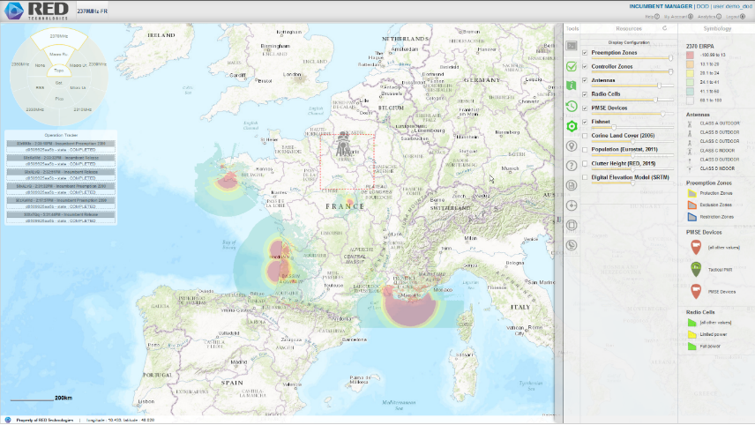
- Wireless Camera Video Links protected by dynamic Protection Zones, and
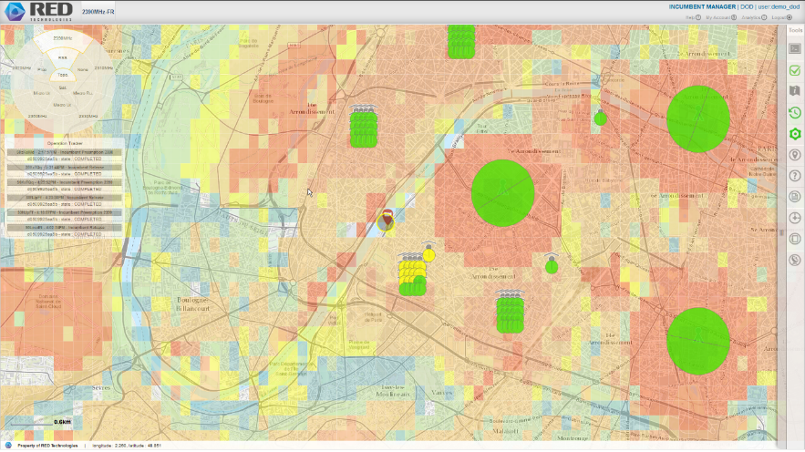
- Tactical PMR protected by dynamic Protection Zones.
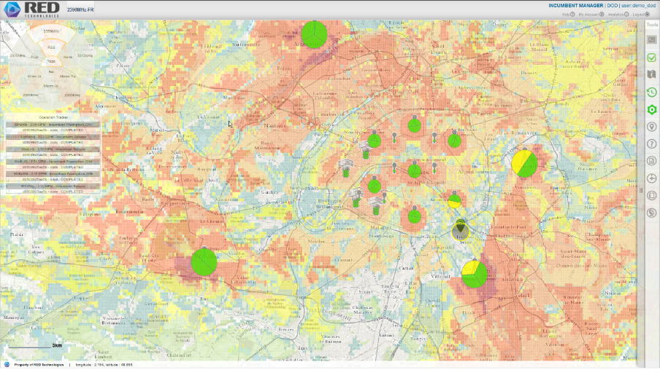

Pilot Layout
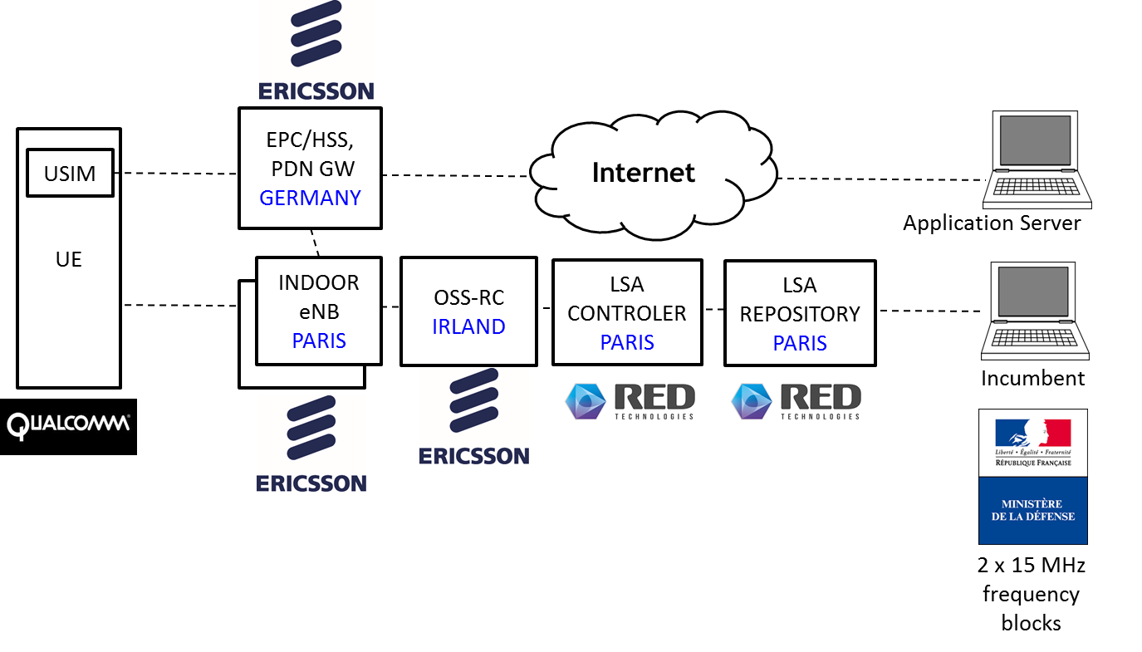

Relevance with Regulatory and Standard bodies
The incumbent protection criteria and sharing rules were derived from the following documents:
- ECC Report 172: Broadband Wireless Systems Usage in 2300-2400 MHz
- ECC Report 205: "Licensed Shared Access (LSA)"
- ECC Report 219: Characteristics of PMSE digital video links to be used in compatibility and sharing studies
- CEPT Report 055: "Harmonized technical conditions for the 2300-2400 MHz in the EU for the provision of wireless broadband electronic communications services"
- CEPT Report 056: "Technological and regulatory options facilitating sharing between Wireless broadband applications (WBB) and the relevant incumbent service/application in the 2.3 GHz band"
- CEPT Report 058: "Technical sharing solutions for the shared use of the 2300-2400 MHz band for WBB (Wireless Broadband) and PMSE"
- ANFR Sharing study « Introduction des mobiles large bande à 2,3-2,4 GHz dans un contexte d’accès partagé au spectre sous licence (LSA, Licensed shared access) »
Furthermore, in order to ensure relevance and raise maximum interest from the industry, the LSA Repository and LSA Controller implementation was developed in compliance with:
- ETSI TS 103 154, “Reconfigurable Radio Systems (RRS); System requirements for operation of Mobile Broadband Systems in the 2300 MHz - 2400 MHz band under Licensed Shared Access (LSA)”
- ETSI TS 103 235, "Reconfigurable Radio Systems (RRS); System Architecture and High Level Procedures for operation of Licensed Shared Access (LSA) in the 2300 MHz-2400 MHz band"
- ETSI TS 103 379, “Information elements and protocols for the interface between LSA Controller (LC) and LSA Repository (LR) for operation of Licensed Shared Access (LSA) in the 2300 MHz-2400 MHz band”
- 3GPP TR 32.855, Study on OAM support for Licensed Shared Access (LSA); (Release 14)
- 3GPP TS 28.302 LSA controller (LC) Integration Reference Point (IRP) Information Service
The pilot validates the LSA architecture as defined by CEPT and ETSI and nourishes contributions to standards. Contributions were made based on the experimentation outcomes, and in particular to ETSI TS 103 379, 3GPP TR 32.855, and 3GPP TS 28.302.

Results and takeaways
This pilot goes beyond the state of the art as it considers the combination of LTE carrier aggregation with dynamic use of LSA mechanism that so far was not yet tested and demonstrate successfully the complementarity of both technologies.
Results are:
- It demonstrates a complete implementation of the LSA technology associated with commercial LTE radio and user equipment
- It validates the LSA architecture and nourishes many contributions to ETSI and 3GPP.
- It provides MNOs with an insight into LSA functions through on-site demos.
- It validates timely dynamic pre-emptions to guarantee protection of the incumbent users.
- It validates the association of carrier aggregation with LSA to guarantee service continuity for LSA licensee users.
Takeaways are
- RED LSA Repository and LSA Controller easily integrated with Ericsson Network Manager and RAN Radio DOTs
- It was the 3rd trial on LSA in EU after Finland and Italy.
- Intra or Inter band Carrier Aggregation allows for no service interruption (LSA Licensee) when Primary Component Carrier (PCC) is on exclusive frequency block.
- LSA is frequency agnostic and can apply similarly to other bands such as 3.4 – 3.8 GHz band.
- LSA helps increasing network capacity in spectrum & accelerates harmonization of IMT bands.
- LSA has no impact on the operator’s desired QoS policies and strategies.
- LSA is fully transparent to UEs

http://www.anfr.fr/publications/etudes/etudes-en-vue/#menu2

